What others say

Don’t just take our word for it. See why other people to professional athletes gotta have their BeetBoost™!



“Beet Boost is a great example of an extremely functional food that allows you to compete at your best. The athletes I work with enjoy the convenience but more importantly, the improvement in their performance.  The reduction of oxygen consumption and the delay of fatigue by 15% is significant to all my athletes.”

Lisa McDowell, MS, RD, CSSD

Team Sports Dietitian, Detroit Red Wings

“I tried BeetBoost when I ran my 50k, drank 30 minutes before start time and again at the half way point… my endurance was amazing…my recovery time unheard of. I was back at it the next day. Amazing.”

Chencho Lopez

San Benito, TX

Obstacle Course Racer

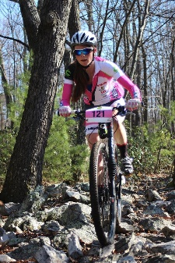

"With BeetBoost I feel really good, am able to sustain a good pace and stay very focused. I am surprisingly not sore and my recovery is very quick."

Vicki Barclay, Ph.D

Elite Mountain Bike Racer

Director of Clinical Research

The Institute of Musculoskeletal Science & Education

“After trying Beet Boost this weekend, I can hardly wait to stock up on Nutrigardens products for myself, my family and my clients! Very refreshing, no sugar or other controversial ingredients I try to avoid and today is day#3 and I already noticed I feel better (pain issues) and energized.”

Joy-Marie Peterson, Portland, OR

"BeetBoost helps me recover faster so I can train harder. It tastes good and is easy on the stomach, overall a very good performance product.”

Addie Bracy

Distance Runner

Longmont, CO

"Beet Boost saves my day on a regular basis. I'm a fitness coach and don't always have time to eat between workouts- I love that I can get from powder to juice to POWER in less than two minutes. Great, healthy taste and convenient packaging. My favorite part is that there are no added sweeteners, just pure nutrients so the energy boost I get doesn't result in a crash (like you find with other energy drinks and packaged protein shakes). NutriGardens for the win!"

Ellen Beaman, Yoga Studio Owner and Instructor, Portland, OR

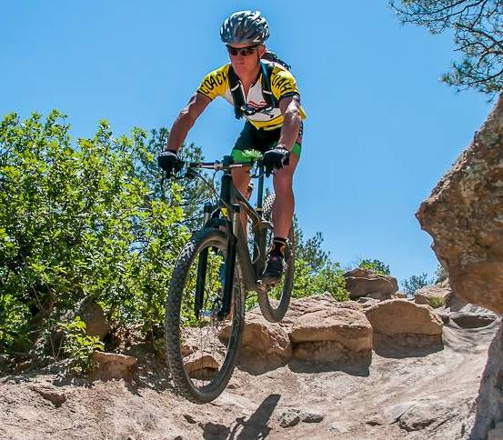

“I used BeetBoost on some high intensity race practice training rides. I liked the not too sweet slightly tart flavor. I was able to do two weekends of training where both days I was putting out big efforts for about 3 hours. I don't do that often, so it was nice feeling strong.”

Kip Biese

Professional Mountain Biker and Coach

Colorado Springs, CO

“I used BeetBoost before and during long runs (5 + miles) and 2 hour exercise classes.  I liked that it didn't make me all nervous and hyper like some other products I bought from GNC and used.  I didn't mind the taste, but it wasn't exactly refreshing.  I did notice that I was able to exercise (run and exercise class) for longer periods of time when using it as opposed to not using it.  (i.e. I didn't fatigue as quickly). My average run mile time improved when I used it.  I also noticed that I wasn't as sore afterwards when I used your product.  I have tendonitis in my right shoulder and the pain and inflammation didn't flare up nearly as bad when I used BeetBoost.  Rather the inflammation was quite mild. Also, as a practicing vegetarian I appreciate that your product is vegan/vegetarian friendly.  I would recommend the product to friends.” – Daniel Connell

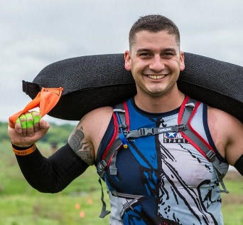“I did notice a lot of mental clarity, my endurance went way up! I could work out faster, longer and harder! Recovery was quick too. All around I felt like super man! You've made an awesome product man!”

Matthew Gambino

Obstacle Course Racer

Angelton, TX

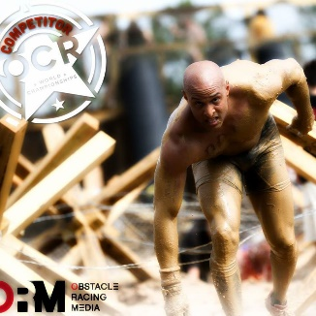“I take BeetBoost about 15 minutes before my training runs. All of my runs are easier and it takes less time to recover. I am able to up my pace without any noticeable effort.”

Paul Dulin

Obstacle Course Racer

Charlotte, NC

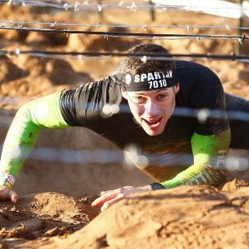“I use BeetBoost for my long Sunday workouts - 12 mile trail run with heavy carries along the way (sandbags, logs, buckets). On these mornings, I always eat and drink the same exact thing, and I'm able to determine which supplements work for me. BeetBoost has definitely increased my endurance throughout this workout, and I've also noticed my heart rate does not spike as easily as without it.”

Justin Chandler

Elite Obstacle Course Racer and Trail Runner

Indianapolis, IN

“I took BeetBoost before a submax VO2 test, as well as before one of my obstacle course races. I felt like I could go longer than usual before feeling fatigued and hitting a wall.”

Corinna Coffin

Professional Obstacle Course Racer

Blacksburg, VA

“I used it before the Belgian Waffle Ride this weekend. It was a 143 mile / 11k ft day and a good portion of it was on dirt! I felt steady and strong all day. I add it to my water bottles for a bit of extra nutrients and calories in the middle of the ride. The packet helps it travel well in my jersey. :)” - Tracy Chandler

“I absolutely love BeetBoost.  It’s simple, easy to use, it’s raw and I don't have to make a mess juicing beets in my juicer! Perfect for on the go!”

Megan Monroy

Triathlete

Los Alamitos, CA

"As a big believer in the power of beets and cherries, I was immediately hooked on my first experience with BeetBoost. Rick, the founder, is a chef by trade, and he has created a unique blend of flavors that I use before the first of many workouts of the day. Traveling often, and 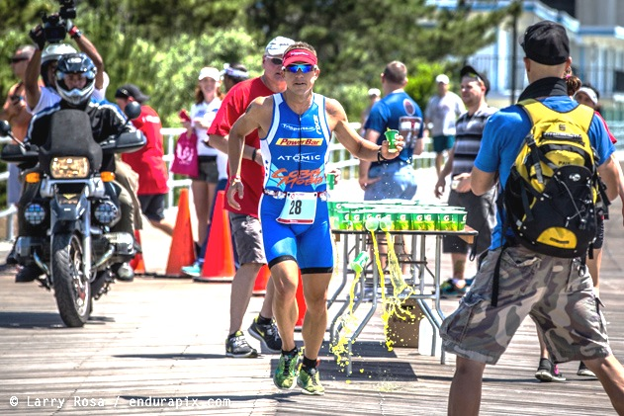buying and steaming beets is a time-consuming process. In addition, you can't take liquids like bottled beet juice for air travel so BeetBoost becomes a great way to travel with beets. The BeetBoost packets make consuming beets on the go a simple and convenient way to make a tasty energizing beverage while gaining the powers of beets and tart cherries."

Thomas Gerlach, Professional Triathlete

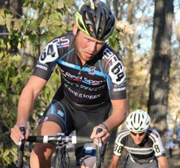“I am currently in the middle of nursing school and trying to be an elite cyclist at the same time.  Between clinical, tests, training, and racing I have little time for relaxation.  Millions of people have this same predicament no matter what their situation is.  I used to drink energy drinks full of caffeine and sugar.  It gave me about a ten minute jolt and then I went back to being tired and feeling guilty because I know it was not good for my body.  Next, I got a hold of BeetBoost.  The refreshing taste and easy to mix packets are something my mind and my body look forward to everyday.  It gives me a long lasting energy that is easily noticed without the crash and guilt of energy drink and other artificial substitutes.  I can be proud of my health choices and carry on to get through my day of training and school with the up-most confidence that I performed my best in every situation that I was put in.  As a cyclist, student, and regular Joe, I recommend BeetBoost to any person that holds an interest in getting the most out of their day while giving the most back to their body and mind.”

Tanner Hurst

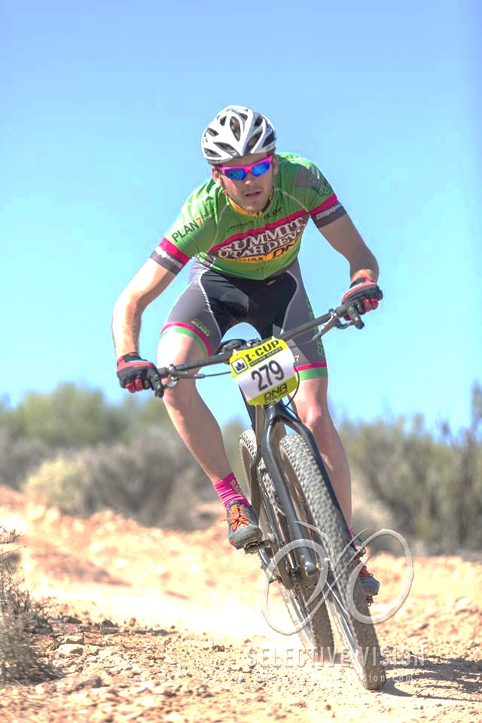

"Energy went straight to my legs. They could push just a little longer. I did feel a higher sense of mental clarity. My focus was improved. I felt like I could go just as hard the next day.”

Jason Christiansen

Mountain Bike Racer

Lindon, UT

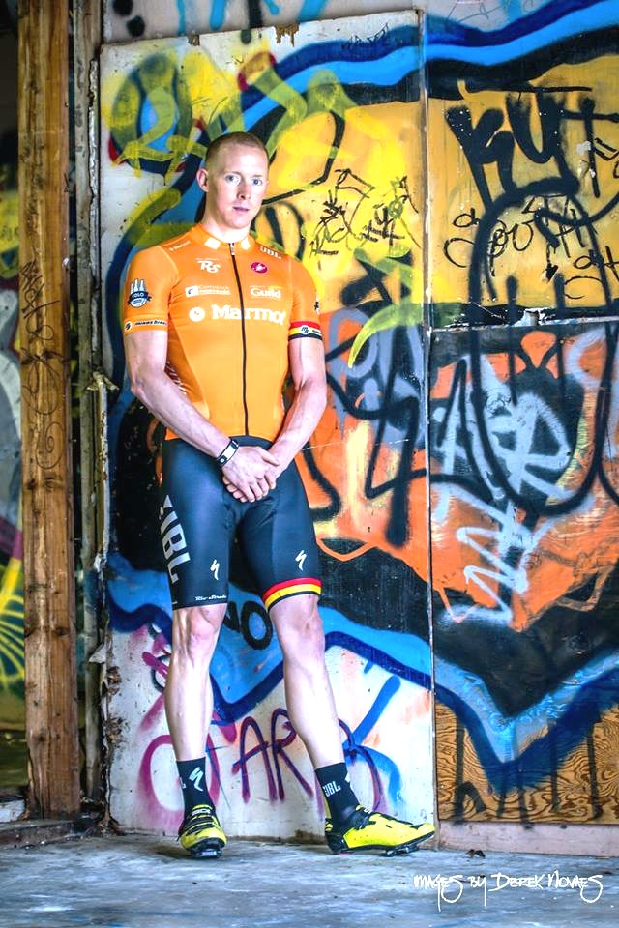

"BeetBoost gives me a surge of stamina and endurance.”

Joshua Tipton

Team Cyclist

Sacramento, CA

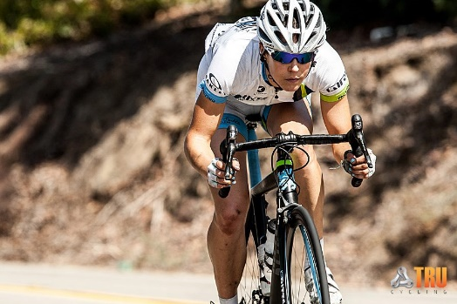

"I notice improved energy - it felt better to go hard than normal. And, i am able to exercise longer.

I notice improved mental clarity!  I feel way more focused while riding, and also I've had it while sedentary too and feel more focused and clear headed.”

Erin Lamb

Team Cyclist

Newbury Park, CA

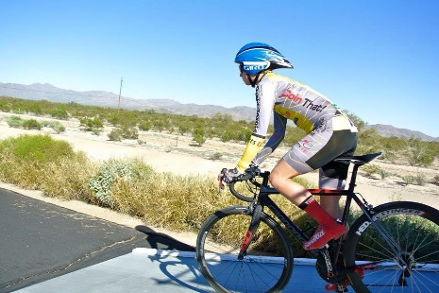

"I use BeetBoost before my races and do very very well. I love BeetBoost so much. It gives lots of clear energy that doesn't make you crash and makes you feel natural about it.”

Charlotte Backus

Larkspur, CO

Team Cyclist

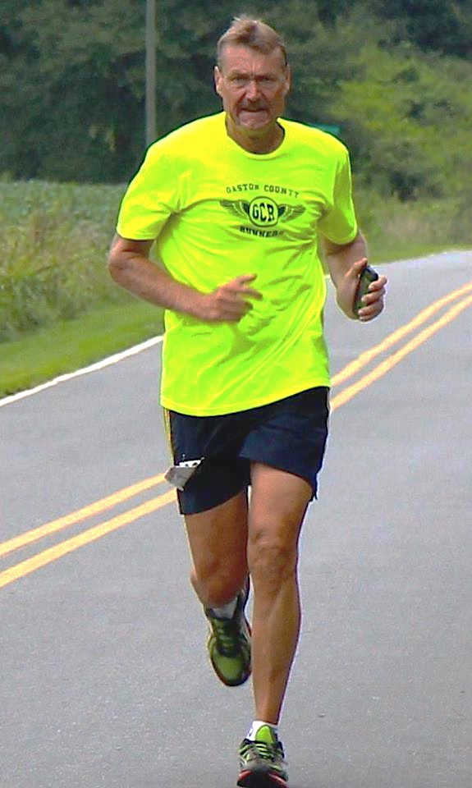“I used BeetBoost at a marathon and a 71-mile bike race with 6000 foot of elevation. Both times I noticed that I never ran out of energy. I recommend BeetBoost to everyone.”

Mitchell Rippy

Shelby, NC

Marathon Runner

"What I LOVE is how I feel after I drink Beet Boost. I have been drinking it in the afternoon right about the time I start to feel that 'I need a nap' feeling. It gives me renewed energy and doesn't spike my blood sugar. In fact, I've been surprised how it has helped control my hunger cravings until dinner time!"

--Sean Harry  
Portland, OR



“I use BeetBoost for heavy lift days and I felt a great pump and clear and focused mind. I love how clean the BeetBoost is... that really matters to me, and it tastes great.”

Candie Bobick

Chicago, IL

Obstacle Course Racer

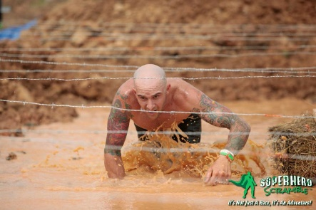“I love BeetBoost. It lowers my heart rate during exercise and it tastes great!”

Dennis Wayne Welch

Middleton, RI

Obstacle Course Racer

“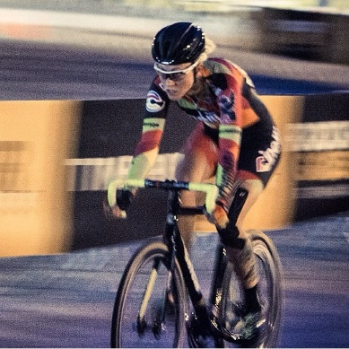My new go to drink mix isn't your typical sugary one, its BeetBoost! I love the natural flavor and energy it gives me!”

Kelli Samuelson

Los Angeles, CA

Owner and Rider for LA Sweat Women's Team

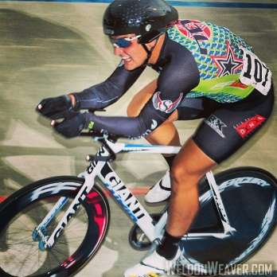

"BeetBoost made me feel alert, not like elevated heart rate alert but focused! Very clean tasting and natural.”

John Croom

Rick Hill, SC

Elite Track Cyclist

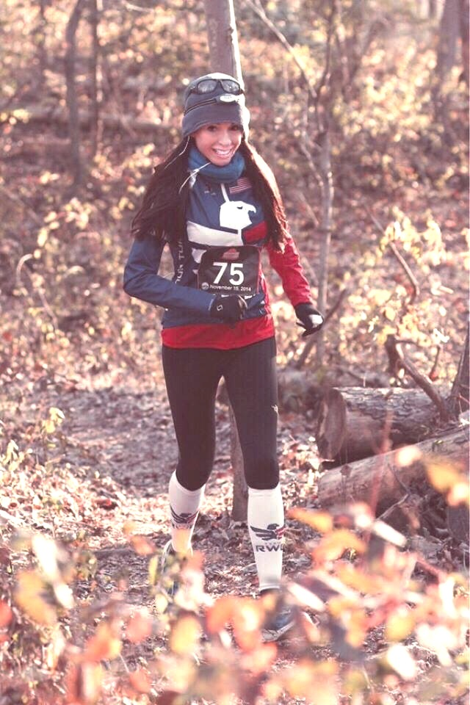

"BeetBoost helped in reducing lactic acid buildup in my legs at the beginning of my run and reduced soreness and fatigue upon recovery.  I took BeetBoost 30-40 minutes prior to all three 16 mile runs.  Because of the fresh feeling in my legs, I do believe I was able to maintain more mental clarity and was more consistent with pacing during the runs."

Stephanie Chivis

Alexandria, VA

Nutritionist, Fitness Instructor and Runner

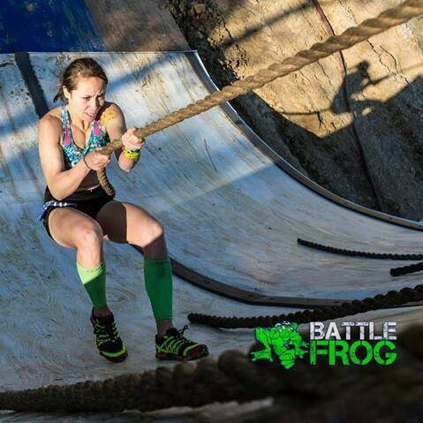

“I absolutely love Beet Boost! Gives me the fuel I need to crush a workout!”

Melanie Chargualaf

Angelton, TX

Mother, Pro Cyclist and Obstacle Course Racer

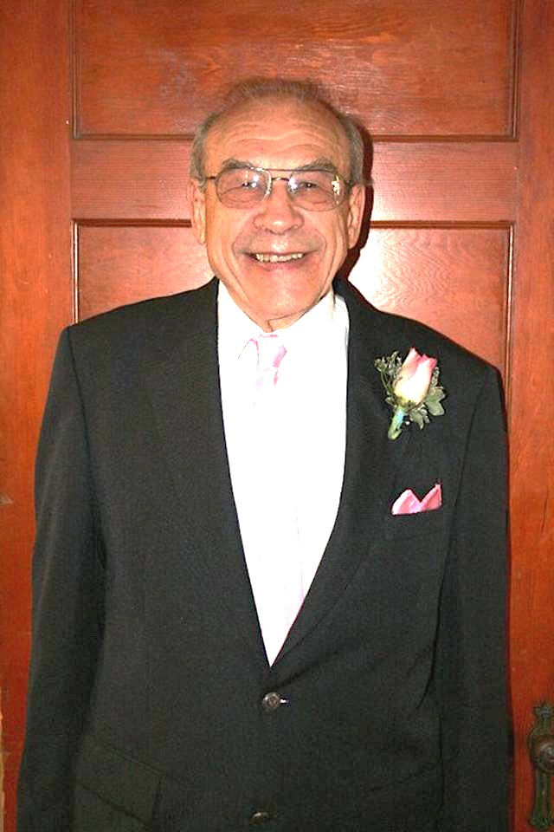

"I am 88 and a long-term cardiac patient. I could not walk, drive, or do mild exercise without getting physically and mentally exhausted and having serious shortness of breath. BeetBoost has given me renewed energy and now I can go grocery shopping and do regular exercise twice daily—all without exhaustion, mental or physical, or breathing problems."

Walter Manchur

Ashland, OR

“I enjoy Beet Boost very much. I live an active lifestyle and have been a Gatorade/coconut water/electorlyte drinker over the years. Beet Boost is good tasting (my wife actually liked it, she's not one for new flavors) and it brought hydration and energy.”

Andrew Pelsma

Escondido, CA



“I enjoy drinking BeetBoost. It has a delicious taste and gives me a surge of energy that makes working out a breeze. It's given me a new perspective on health.”

Albert Kaufman



I LOVE the BEET BOOST! It is yummy and it helps me with maintained energy!

Znette Blakeman

“I had trouble getting beyond the flavor, but once it was in my system, it worked as expected.  It kept the inflammation out of my knees and shoulders for an extended time.  As a person who juiced beets, I find this to be very convenient.  I did not find an extra boost of energy though, which I was maybe thinking would occur, but again, fatigue was heavily delayed!”

David Liggett